ADAR-MASTER PROJECT OUTLINE (PLAN) version 2 (Final)

Group 2

Andrew Muteka

Rendemptus Amputu

Niclas Shilongo

Joseph Muhepa

HONOURS STUDENTS’ REPORTS REPOSITORY

Table of Contents

1. Document Information 3

1.1 Document Revision History 3

1.2 Document Audience 3

2. The Original System 4

2.1 Overview 4

2.2 Installation Requirements 4

2.3 System Flow 5

2.3.1 Landing Page 5

This is the first page, 5

2.3.2 Successful Login Page 6

2.3.3 Navigation 6

2.3.4 All Entries 7

2.3.5 Capture 8

2.3.6 New Contact 10

2.4 Entities of AdAr 11

2.4.1 Contacts Table 11

2.4.2 Countries Table 11

2.4.3 Items Table 12

2.4.4 Tags Table 12

2.4.5 Users Table 13

3. System Revamp 13

3.1 Our Objectives 13

3.2 Software Development Process Model 13

3.3 Implementation plans: 14

3.3.1 Project Schedule 14

3.3.2 Wireframe 15

4. Conceptual Database Design 24

5. Challenges and Risks Preparations 26

5.1 Environmental Setups and Project Cloning 26

5.2 Project Resourcing and Management 26

6. Project Expectations and Results 27

7. Project Monitoring 27

8. Glossary 27

Table of Tables

Table 1: Document Information 3

Table 2: Document Revision History 3

Table 3: Document Audience 3

Table 4: Contacts Table 11

Table 5: Countries Table 11

Table 6: Items Table 12

Table 7: Tags Table 12

Table 8: Users Table 13

Table 9: Project Schedule 14

Table 10: Papers Table 25

Table 11: Users Table 25

Table 12: UserType Table 25

Table 13: User Login Account Table 25

Table 14: Cluster Table 26

Table 15: Country Table 26

Table 16: Glossary table 27

Table of Figures

Figure 1: The Landing Page 5

Figure 2 Login Check 6

Figure 3 Navigation Panel 7

Figure 4 All Entries 7

Figure 5 New Data Set 1 8

Figure 6 New Data Set 2 9

Figure 7: Add New Contact 10

Figure 8 New Login Page 15

Figure 9 View Research Panel 16

Figure 10 Lecturer (Supervisor) Panel 17

Figure 11 Student Panel 18

Figure 12 Coordinator Panel 19

Figure 13 Moderator Panel 20

Figure 14 lecture grade allocation 21

Figure 15 publish and unpublished research 22

Figure 16 Receive Research 23

Figure 17 enrol student by the coordinator 24

# Document Information

|  |  |  |
| --- | --- | --- |
|  | **Information** | |
| Document Owner: | ASD Group 2, NUST Students | |
| Document Title: | Adar master Project Outline - System Specification Document | |
| Document Authors: | Mr Andrew Muteka |  |
| Mr Rendemptus Amputu |  |
| Mr Niclas Shilongo  Mr Joseph Muhepa | |
| Document Version Number: | 2.0 | |
| Creation Date: | 3 March 2019 | |
| Completion Date: |  | |
| Last Saved Date: | 14 March 2019 | |

Table : Document Information

## 1.1 Document Revision History

|  |  |  |  |  |  |
| --- | --- | --- | --- | --- | --- |
| **Ver** | **Date** | **Comments** | **Requested Change** | **Requested By** | **Changes Made By** |
| 1.0 | 03/03/2019 | Document created | N/A | N/A | R. Amtupu |
| 2.0 | 13/03/2019 | Document Reviewed | Review | C. Stanley | A. Muteka |

Table : Document Revision History

## 1.2 Document Audience

|  |  |  |
| --- | --- | --- |
| **Name** | **Designation** | **Project Role** |
| Mr Colin Stanley | Lecturer: Advanced Software Development | Project Executive |
| Mr Andrew Muteka | Student: Advanced Software Development | Team Member/ Developer |
| Mr Rendemptus Amputu | Student: Advanced Software Development | Team Member/ Developer |
| Mr Niclas Shilongo | Student: Advanced Software Development | Team Member/ Developer |
| Mr Joseph Muhepa | Student: Advanced Software Development | Team Member/ Developer |

Table : Document Audience

# The Original System

## 2.1 Overview

The digital image archiving system, Another Dumb Archive better known as Adar, which literary mean uncertain, was development based on the system Digital Image Archive Saffig (DiBaS), which was developed for the archiving of the photo collection of the history association Saffig. Saffig is a municipality in the district of Mayen-Koblenz in Rhineland-Palatinate, western Germany.  In this project, the system was supplemented by document-relevant functions such as Optical Characteristic Recognition (OPR), contact management and others. The system is for data storage. PDF files are generated with text tool and then uploaded to the database. AdAr is currently only available in German. We had to translate labels and comments to English during system revamping.

## 2.2 Installation Requirements

The system requires the following for it to be run on the local machine:

* Requires a web server with PHP 7 or greater, gif draw-able (GD) and exchangeable image file format (EXIF) support in it.
* Requires server with Internet Protocol version four (IPv4) access (Github does not yet support IPv6)
* Requires a MySQL / Maria DB databases
* Requires composer
* tesseract> = 3
  + To run OCR on graphics
  + not really tested, language German default
* pdftotext
  + For extracting text from PDF files
* imagemagick
  + or its convert to convert image data

These links are supportive with the installation of this project, for more information click on them to get additional clarified information:

<https://github.com/adlerweb/adar>

<https://www.adlerweb.info/blog/tag/adar/>

## 2.3 System Flow

This section is a going to describe how the existing system work. After successful installation of the system, here is what happen once the program is launched.

### 2.3.1 Landing Page

This is the first page, Figure 1: The Landing Page of the program. It consists of the login form that authenticates the usage of the system. For a user to continue using the system or accessing other pages of the system, he or she needs to have the right authentication toward the system, that is the right user name and the password. This is bad design because it does not allow some content to be viewed without logging in first.

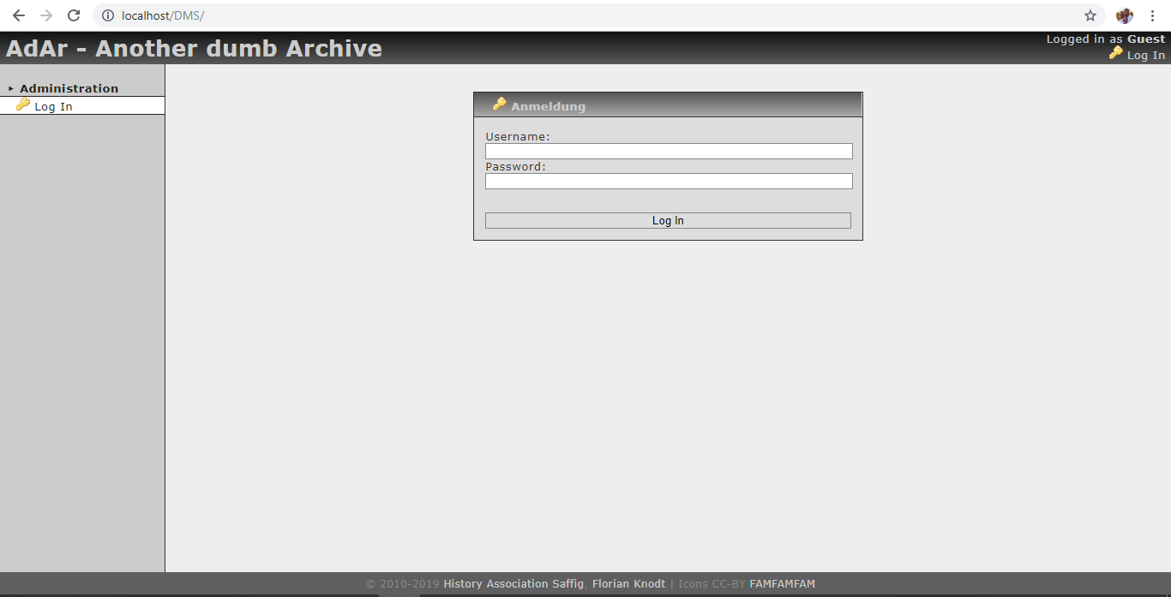

Figure : The Landing Page

### 2.3.2 Successful Login Page

This Figure 2 Login Check is to check if a user has entered the right credential to autheticate the system usage. In this case a user has entered the right credentials. If a user clicks on the to “To the main navigation” link on the display on Figure 2 Login Check, the Figure 3 Navigation Panel will then appear.

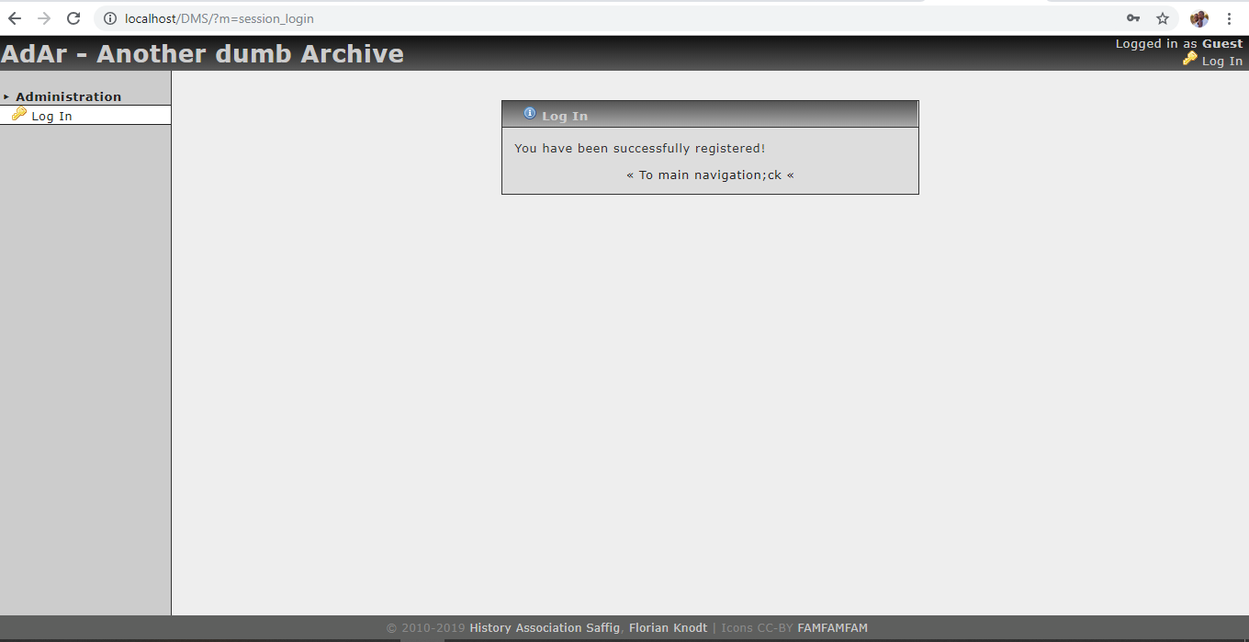

Figure Login Check

### 2.3.3 Navigation Panel

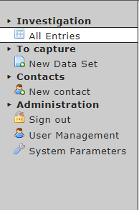The figure, Figure 3 Navigation Panel, shows the navigation panel or the main menu that an authenticated user has on the system. On this panel, a user can click variety of links to operate different tasks on the system.

Figure : Navigation Panel

Here is the description of what the links in Figure 3 Navigation Panel does once clicked:

* **All entries:** this link will display all entries that have been entered in the system.
* **New Data Set:** this is where a user will be given option to add the new dataset to the system database
* **Sign out:** by clicking this option a user can then be signed out of the system whereby the session is destroyed.
* **User Management:** The super user is able to grant different access to system users through this link. Not functional.
* **System Parameters:** through this link, the super user will then be able to set the parameters of the system. Not functional.

### 2.3.4 All Entries

Figure 4 All Entries is a display of how the view display of entries will look. Only ten rows will be shown by default, a user is given the option to display as more rows by changing the entry values. A user can also navigate this with the pagination option by clicking back or next depending on the choice.

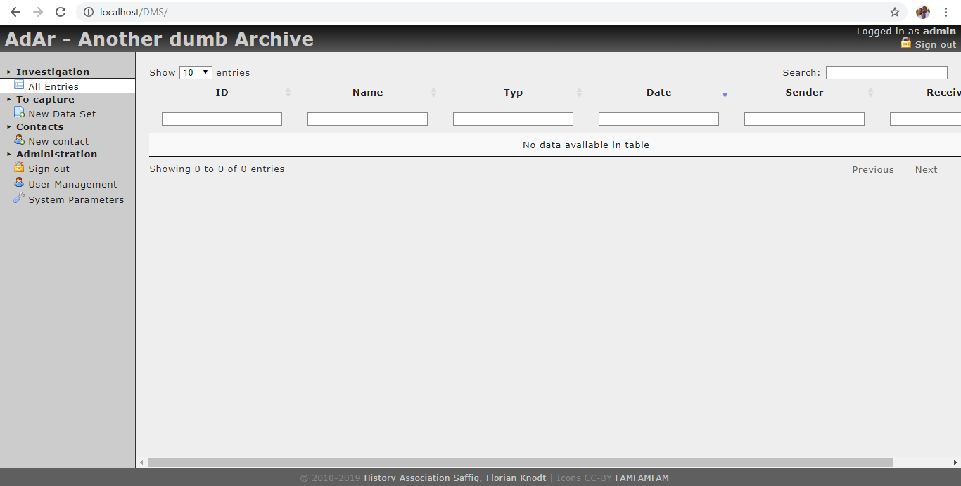

Figure All Entries

### 2.3.5 Capture

If New Data Set is clicked, Figure 5 New Data Set 1 will appear. This is the first part of this option whereby the user will be prompt to choose a file from the local machine and upload it. When the file is successfully uploaded , Figure 6 New Data Set 2 will then appear.

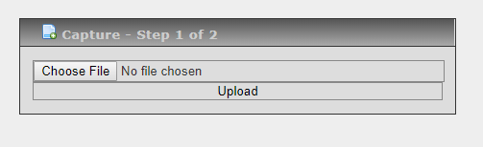

Figure New Data Set 1

In Figure 6 New Data Set 2 is where the user will be asked to add the metadata of the system as the same figure shows.

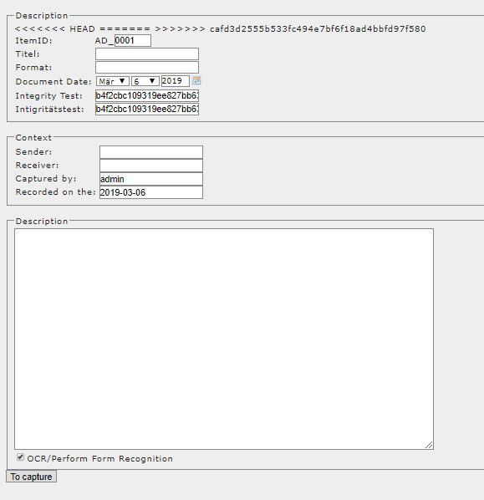

Figure New Data Set 2

### 2.3.6 New Contact

The Figure 7 Add New Contact, is for capturing a new contact on the system. This function allows a new contact to be captured into the system. A user will complete this form to add the new contact as prescribed.

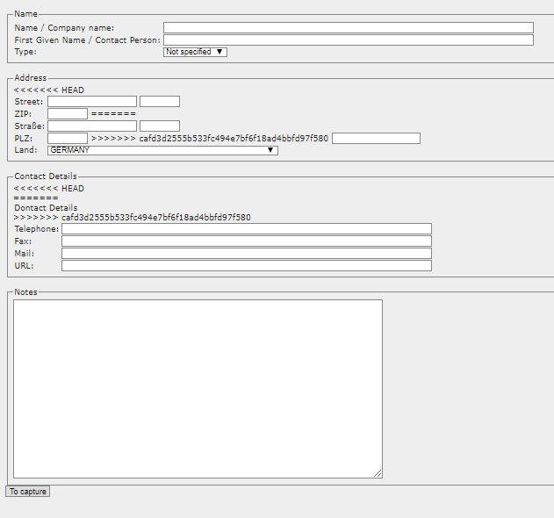

Figure : New Contact

## 2.4 Entities of AdAr

The following section has a list of database tables representing the entities in the system. All the column names and attributes of the current system.

### 2.4.1 Contacts Table

This is the table that will be saving the contacts that will be added to the system. The records will be inserted as Table 4: Contact Table illustrates.

|  |  |  |  |  |
| --- | --- | --- | --- | --- |
| Name | Description | Datatype | Default Value | Null able |
| CID | Primary Key | NUMBER |  | No |
| FamilyName |  | TEXT |  | No |
| GivenName |  | TEXT |  | No |
| Type | (m)ale, (f)emale, (u)ndefined, (c)ompany | ENUMRATOR | 'm', 'f', 'u', 'c' | No |
| Street |  | TEXT |  | No |
| Housenr |  | TEXT |  | No |
| ZIP |  | TEXT |  | No |
| City |  | TEXT |  | No |
| Country |  | TEXT | DE | No |
| Phone |  | TEXT |  | No |
| Fax |  | TEXT |  | No |
| Mail |  | TEXT |  | No |
| URL |  | TEXT |  | No |
| Notes |  | TEXT |  | No |

Table : Contacts Table

### 2.4.2 Countries Table

This Table5: Countries Table is where the country name will be stored as reflected by the same table.

|  |  |  |  |  |
| --- | --- | --- | --- | --- |
| Name | Description | Datatype | Default Value | Null able |
| Alpha2 |  | TEXT |  | No |
| Name |  | TEXT |  | No |

Table : Countries Table

### 2.4.3 Items Table

This Table: 6 Item Table is where the country name will be stored as reflected by the same table.

|  |  |  |  |  |
| --- | --- | --- | --- | --- |
| Name | Description | Datatype | Default Value | Null able |
| ItemID | using users short-id and a >=4-digit-sequential number - example: FK_0003 | TEXT |  | No |
| Caption | Free text to describe the document | TEXT |  | No |
| Description | Contains detailed description and data gathered from EXIF or OCR | TEXT | NULL | Yes |
| Format | Free text to describe physical source of this document - (letter, photo, whatever) | TEXT | NULL | Yes |
| Date | originals date | DATE | NULL | Yes |
| Sender | source (needs to be changed) | NUMBER |  | No |
| Receiver |  | NUMBER |  | No |
| ScanUser | scanning user | NUMBER |  | No |
| ScanDate | scanning date | DATE |  | No |
| SourceSHA256 | SHA256 of archived document to check for corrupted files | TEXT |  | No |
| OCRStatus |  | NUMBER | 0 | No |

Table : Items Table

### 2.4.4 Tags Table

This Table 7: Tags is where the items meta data will be stored as tags as reflected by the same table.

|  |  |  |  |  |
| --- | --- | --- | --- | --- |
| Name | Description | Datatype | Default Value | Null able |
| TagID | Primary Key | NUMBER |  | No |
| ItemID |  | TEXT |  | No |
| TagValue |  | TEXT |  | No |

Table : Tags Table

### 2.4.5 Users Table

This Table 8: Users is where the country name will be stored as reflected by the same table.

|  |  |  |  |  |
| --- | --- | --- | --- | --- |
| Name | Description | Datatype | Default Value | Null able |
| UserID | Primary Key | NUMBER |  | No |
| Name |  | TEXT |  | No |
| Nickname | aka login name | TEXT |  | No |
| Password | salted SHA256 | TEXT |  | No |
| Email |  | TEXT |  | No |
| Level | binary system, not really documented yet | NUMBER |  | No |
| UIdent | two chars used as user-identifier for document IDs | TEXT |  | No |

Table : Users Table

# System Revamp

## 3.1 Our Objectives

The main reason we chosen this project is to enable us to target a specific audience. This primary audience is to use the system for archiving of Research Reports by honours students in Computer Science ideally for University of Science and Technology (NUST). Staff members and research students should be able to search the document repository for topics and research report.

The secondary target audience is other faculties of NUST at honours research level and anyone else who would like to use this application free of charge.

## 3.2 Software Development Process Model

The project is going to be developed using Agile Modelling. This is an incremental model in rapid cycle.

This process will enable the developers to develop the project base on the previous development. For each piece of the project release there will be testing to be done before committing such changes. Looking at the complexity of the project it has derive the developers to choose such a great method of development.

## 3.3 Implementation plans:

### 3.3.1 Project Schedule

The project schedule is represented by Table 9 below.

|  |  |  |  |
| --- | --- | --- | --- |
| # | Week Starting on | Tasks/ Functions | Resource |
| 1 | 4 March 2019 | Familiarisation with selected project | Development team |
| 2 | 11 March 2019 | User Management | Muteka |
| 3 | 18 March 2019 | Upload of Paper | Shilongo |
| 4 | 25 March 2019 | Notification & Import | Amputu |
| 5 | 1 April 2019 | Database Normalisation | Muhepa |
| 6 | 8 April 2019 | Integration Testing | Development team |
| 7 | 15 April 2019 | Expend on Superior function | TBA |
| 8 | 23 April 2019 | Add moderator function | TBA |
| 9 | 6 May 2019 | More functionalities | TBA |

Table : Project Schedule

### 3.3.2 Wireframe

**Home Panel: Interface Page**

Similar to the old Figure 1 the Landing Page, this landing page Figure 8 new login page also have the same display. Though the displays are the same there are some addition that have been made like the change on title, the new navigator link, “view researches” that enable an normal user to search the reports within the system. There are only role drop down bar that is added to enable different user to login accordance with their roles toward the system.

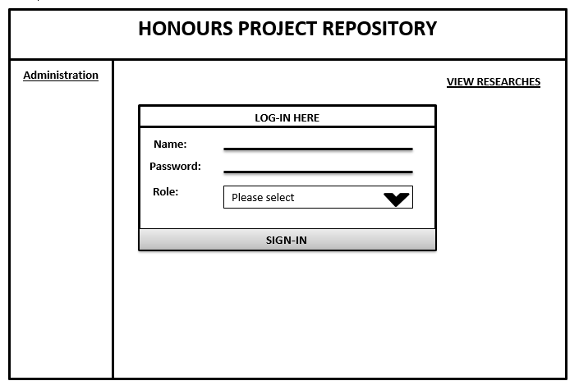

Figure New Login Page

**If A User Clicks View Research**

If any user whether logged in or not, Figure 9 view research panel will then appear whereby the user will be able to view reports as the page illustrates. This will also allow to view them depending on opted day or view all by default.

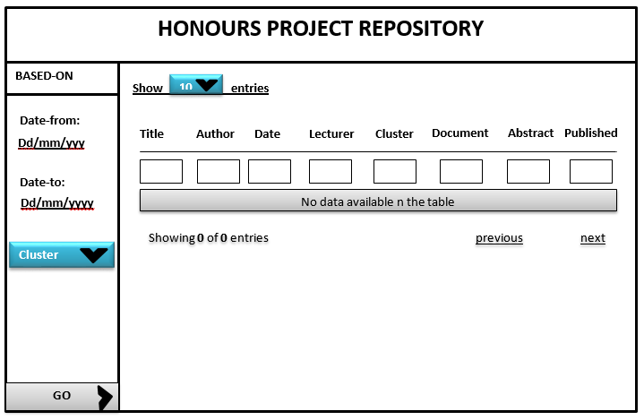

Figure View Research Panel

**If a lecturer logged in successfully**

If a lecturer (supervisor) logged in successful from Figure 8 new login page, The Figure 10 lecturer (supervisor) panel will then appear that will enable the supervisor to view date to upload the research (report). The supervisor will be able to allocate grades, upload reports, and search for the reports and also to receive new researches (reports).

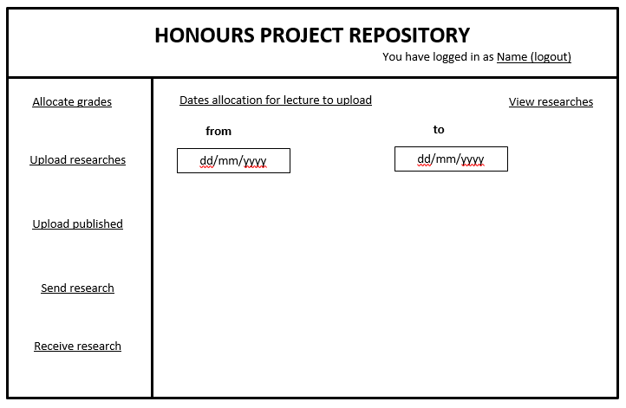

Figure Lecturer (Supervisor) Panel

**If a student logged in successfully**

If from Figure 8 new login page, a student login successfully, he or she will be able to perform the tasks as illustrated by Figure 11 student panel. Basically, there are options that are associated with this panel, send research and view research. This option will allow the students to send the research (reports) for marking as well as to view the grading made by the respective supervisor.

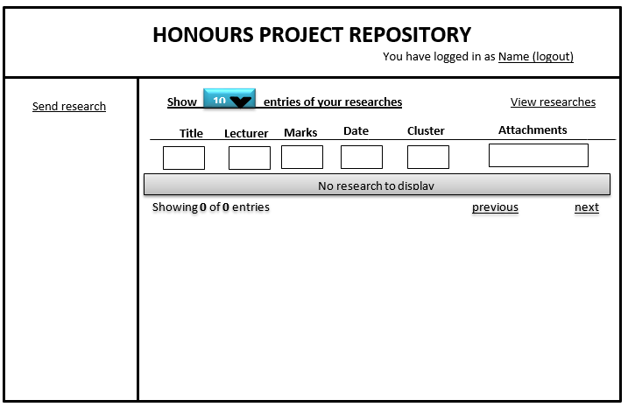

Figure Student Panel

**If a co-ordinator logged in successfully**

Furthermore, if the coordinator logged in successfully in the system the Figure 12 coordinator panel will then be displayed. This will allow the coordinator to set the date of the reaserch to be apploaded. It will also has a further navigation of viewing the research and enroll student.

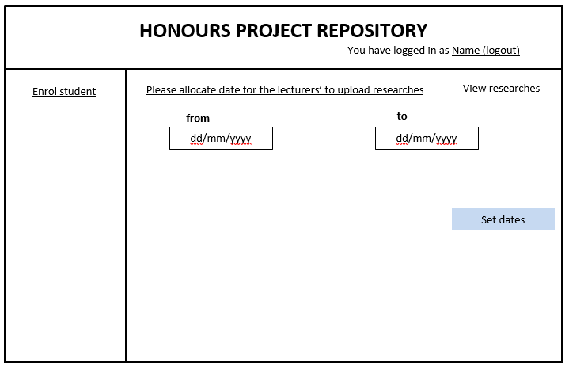

Figure Coordinator Panel

**If a moderator logged in successfully**

Furthermore, if the moderator logged in successfully in the system the Figure 13 moderator panel will then be displayed. This will allow the moderator to set the date of the reaserch to be apploaded.

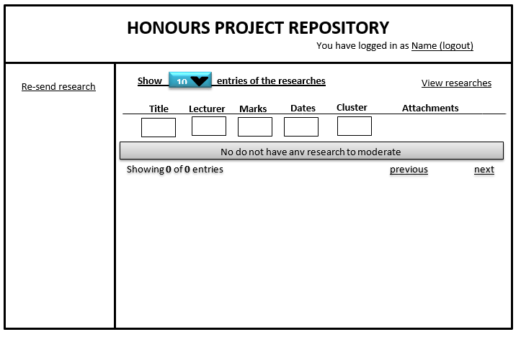

Figure Moderator Panel

**If a lecturer clicks mark allocations**

On the other, if the lecturer (suppervisor)logged in successfully in the system the Figure 14 lecture grade allocation will then be displayed, he or she will be able to navigate through the panel. In this case it is assumed that the the lecturer (supervisor) clicked on marks allocation. The panel will then display as shown by Figure 14 lecture grade allocation.

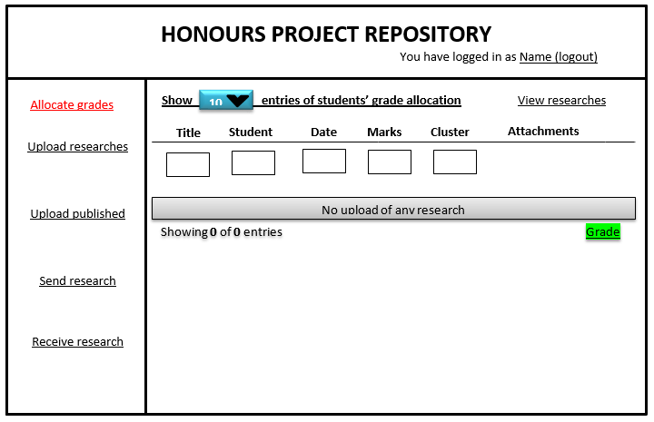

Figure lecture grade allocation

**If a lecturer clicks research upload or published research upload**

If the lecturer (suppervisor)logged in successfully in the system the Figure 15 publish and unpublished research will then be displayed, he or she will be able to navigate through the panel. In this case it is assumed that the the lecturer (supervisor) clicked on marks allocation. The panel will then display as shown by Figure 15 publish and unpublished research.

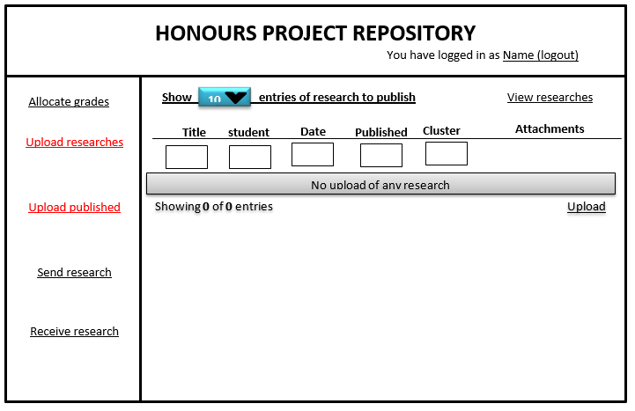

Figure publish and unpublished research

**If a lecturer clicks receive research**

If the lecturer (suppervisor)logged in successfully in the system the Figure 16 Receive Research will then be displayed, he or she will be able to navigate through the panel. In this case it is assumed that the the lecturer (supervisor) clicked on marks allocation. The panel will then display as shown by Figure 16 Receive Research.

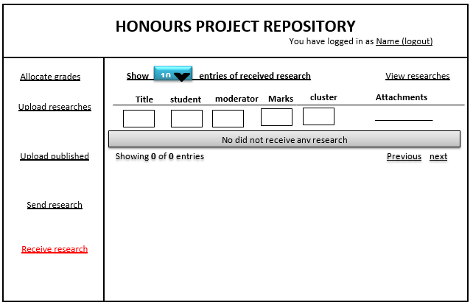

Figure Receive Research

**If a co-ordinator clicks enrol student**

The system will allow the coordinator to enrol student manually or to upload the sheet were the students that will be loaded automatically on the system. This will enable multiple students to be enrolled in the system at once by the single click. Figure 17 enrol student by the coordinator show the form that will be used by the coordinator to enrol students manually though the system will also be provisionally allowing the automatic students enrolment from spread sheets using a single load button.

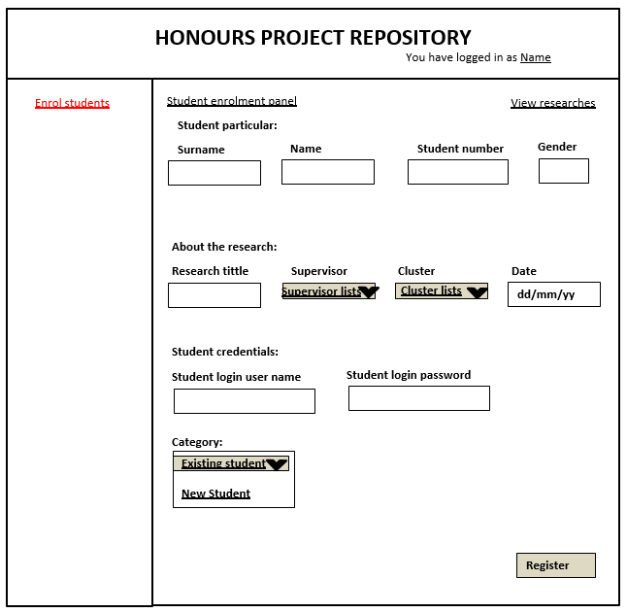

Figure enrol student by the coordinator

# Conceptual Database Design

This is the database designed table that will allow the storage of data that will be captured by the form. These table are going to be saving data from the forms on their respective places, i.e., rows and columns. During the system revamp, the development has come up with some additional table to cater for the new system purposes and these are: Papers, Users, UserTypes, UserLoginAccount, Cluster and country. This table are shown respectively in Table 10: Paper table, Table 11: Users table, Table 12 usertype table, Table 13: UserAccountLogin table, Table 14: cluster table, and table 15: country table.

Papers Table

|  |  |
| --- | --- |
| Name | Data Type |
| paperId | NUMBER |
| dateUpload | DATE |
| dateModerate | DATE |
| dateGrade | DATE |
| lecturerId | TEXT |
| moderateId | TEXT |
| studentNumber | TEXT |
| coodinaterId | TEXT |
| clusterId | NUMBER |
| publishedStatus | TEXT |
| abstract | TEXT |

Table : Papers Table

Users Table

|  |  |
| --- | --- |
| Name | Data Type |
| userId | NUMBER |
| firstName | TEXT |
| Lastname | TEXT |
| statusId | NUMBER |
| contactNo | TEXT |
| Email | TEXT |
| userTypeId | NUMBER |
| Qualification | NUMBER |
| clusterId | NUMBER |
|  |  |

Table : Users Table

UserType Table

|  |  |
| --- | --- |
| Name | Data Type |
| userTypeId | NUMBER |
| typeName | TEXT |
| Description | TEXT |

Table : UserType Table

UserLoginAccount Table

|  |  |
| --- | --- |
| Name | Data Type |
| UserId | NUMBER |
| Username | TEXT |
| Password | TEXT |

Table : User Login Account Table

Cluster Table

|  |  |
| --- | --- |
| Name | Data Type |
| clusterId | NUMBER |
| Clustername | TEXT |
| Description | TEXT |

Table : Cluster Table

Country Table

|  |  |
| --- | --- |
| Name | Data Type |
| countryId | NUMBER |
| countryName | TEXT |
| Abbreviation | TEXT |

Table : Country Table

# Challenges and Risks Preparations

This is a very challenging project from its set, one need to pay attention on every little step to make sure that the local environment of the project is working perfect. There are major challenges that that have been rectified, and these are:

## 5.1 Environmental Setups and Project Cloning

**Project environment:**

* Members of the developing team have to make sure they have setup their environment within their local machines

**Download and installation:**

* Successfully install XAMPP on their machine irrespective of the operating system

**Ports testing and configuration:**

* Making sure the database and the webserver is up and running
* Ports reconfigurations and switching

**On GitHub:**

* Make sure the repository is created for the project where every member is able to pull and push to the repository

**Cloning and local setups:**

* Make sure the project is running on the local machines
* Participating on the group discussion platforms

## 5.2 Project Resourcing and Management

The development team have to make sure that:

* they have familiarize themselves with the language of development, i.e., PHP and MySQL
* Know about git and how it works, at very advance stage
* The main management and discussion forum to be used will be WhatsApp, which is agile style.

# Project Expectations and Results

This project is expected to be successful and provide the following results:

* Allow the saving of contacts
* Saving of research and documents
* Ability to search for documents

# Project Monitoring

The project development team are responsible of monitoring their development phases. Before the meetings at the end of the weekly submissions each member has to take accountability of his development and changes made to the project. The testing of each development will be done by all group members or individually to allow commits.

# Glossary

|  |  |
| --- | --- |
| Term | Description |
| ICT | Information, Communications and Technology |
| SRS | Systems Requirements Specification |
| OCR | Optical Character Recognition |
| Adar | Another Dumb Archive |
| DiBaS | Digital Image Archive Saffig |
| ASD | Advance Software Development |
| TBA | To Be Announced |

Table : Glossary table